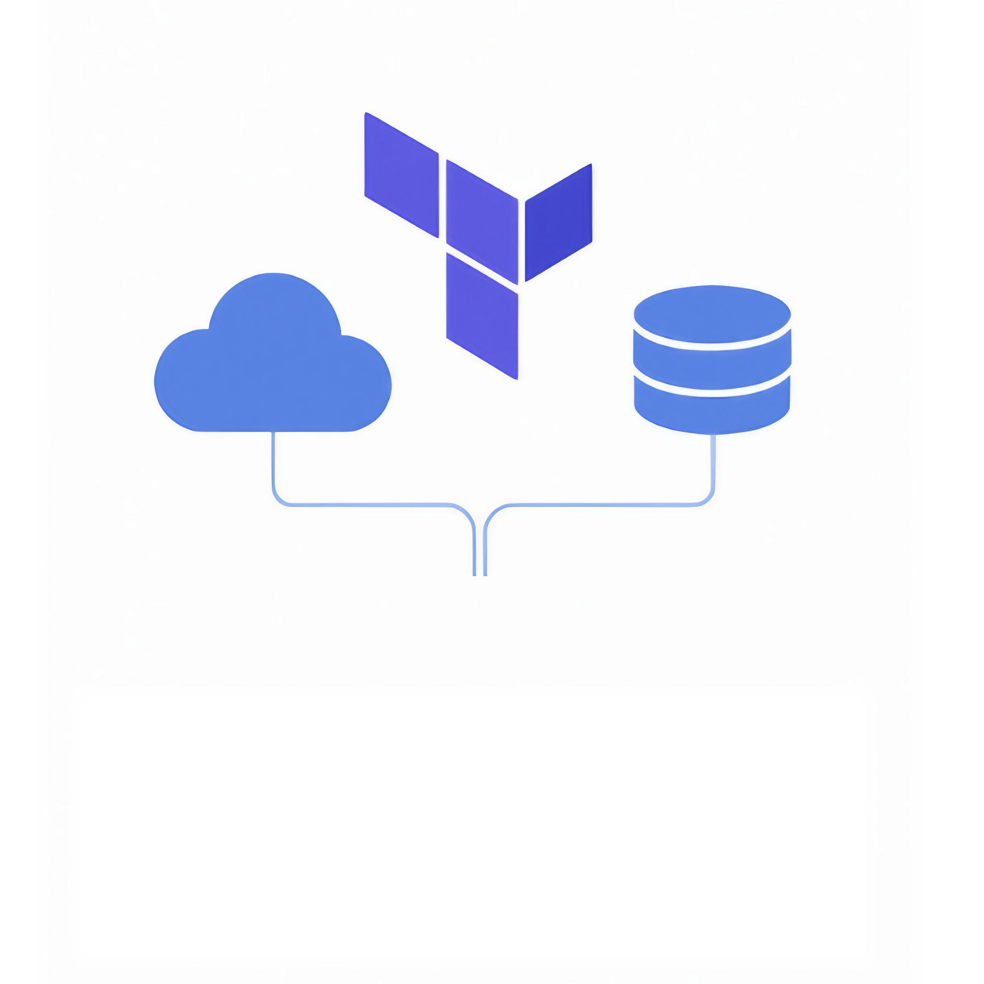**Terraform Quickstart Cheatsheet**

A Curated Cheatsheet of Terraform CLI Commands Organized by Topic

By Kirshi Yin

Curious Devs Corner

2025

# Table of Contents

**Table of Contents** **2**

**Introduction** **3**

**🛠️ Setup & Initialization** **4**

**🧹 Code Formatting & Validation** **4**

**📦 Modules & Providers** **5**

**📐 Planning Infrastructure** **5**

**🚀 Applying Changes** **5**

**🧨 Destroying Infrastructure** **6**

**🔐 Terraform Cloud Authentication** **6**

**📊 State Management** **7**

**🔄 Importing Resources** **7**

**📤 Outputs** **8**

**🧪 Interactive Console** **8**

**🧭 Workspaces** **8**

**🔓 Unlocking State** **9**

**📈 Dependency Graph** **9**

**🧰 Miscellaneous** **9**

**Final Thoughts** **10**

# Introduction

This cheatsheet gives you quick access to the most useful Terraform CLI commands. Keep it open in a tab or download it as a PDF. It’s organized by topic — like init, modules, providers — so you can find what you need fast.

You can use it to look up commands during a project. Or test each one in your own setup if you’re learning Terraform.

*All commands are up to date with the latest Terraform version (v1.12.1).*

# 🛠️ Setup & Initialization

* terraform init # Initialize working directory and download providers
* terraform init -upgrade # Upgrade modules and providers to latest versions
* terraform init -lock=false # Skip state lock during init
* terraform init -input=false # Disable interactive prompts
* terraform init -migrate-state # Migrate existing state to new backend
* terraform -install-autocomplete # Enable CLI autocompletion

# 🧹 Code Formatting & Validation

* terraform fmt # Format code to HCL standard
* terraform fmt -recursive # Format code in subdirectories
* terraform validate # Validate configuration syntax
* terraform validate -json # Output validation results in JSON format
* terraform validate -backend=false # Skip backend validation

# 

# 📦 Modules & Providers

* terraform get # Download modules
* terraform get -update # Update modules to latest versions
* terraform providers # List providers used in configuration

# 📐 Planning Infrastructure

* terraform plan # Show execution plan
* terraform plan -out=plan.out # Save plan to file
* terraform plan -destroy # Show plan to destroy all resources

# 🚀 Applying Changes

* terraform apply # Apply changes to reach desired state
* terraform apply plan.out # Apply changes from saved plan
* terraform apply -auto-approve # Apply without interactive approval
* terraform apply -lock=false # Skip state lock during apply
* terraform apply -parallelism=5 # Limit parallel resource operations
* terraform apply -var="key=value" # Pass variable via CLI
* terraform apply -var-file="vars.tfvars" # Load variables from file
* terraform apply -replace="resource" # Replace specified resource
* terraform apply -target="resource" # Target specific resource
* terraform apply -refresh=false # Skip state refresh before apply

# 🧨 Destroying Infrastructure

* terraform destroy # Destroy all managed resources
* terraform destroy -auto-approve # Destroy without interactive approval
* terraform destroy -target="resource" # Destroy specific resource

# 🔐 Terraform Cloud Authentication

* terraform login # Authenticate with Terraform Cloud
* terraform login <hostname> # Authenticate with specified host
* terraform logout # Remove stored credentials
* terraform logout <hostname> # Remove credentials for specified host

# 

# 

# 📊 State Management

* terraform show # Show current state in human-readable format
* terraform refresh # Update state file with real-world resource data
* terraform state list # List resources in state file
* terraform state show resource # Show details of specific resource
* terraform state mv src dst # Move resource to different address
* terraform state rm resource # Remove resource from state
* terraform state pull > state.tfstate # Download current state to file
* terraform state push # Upload local state file to remote backend
* terraform state replace-provider old new # Replace provider in state

# 🔄 Importing Resources

* terraform import resource_name resource_id # Import existing resource into state

# 

# 

# 📤 Outputs

* terraform output # List all outputs
* terraform output -json # Output in JSON format
* terraform output -state=state.tfstate # Show outputs from specified state file
* terraform output output_name # Show specific output value

### 

# 🧪 Interactive Console

* terraform console # Open interactive console for expressions
* echo 'expression' | terraform console # Evaluate expression via pipe

# 🧭 Workspaces

* terraform workspace list # List all workspaces
* terraform workspace show # Show current workspace
* terraform workspace new name # Create new workspace
* terraform workspace select name # Switch to specified workspace
* terraform workspace delete name # Delete specified workspace

# 🔓 Unlocking State

* terraform force-unlock LOCK_ID # Manually unlock state

# 📈 Dependency Graph

* terraform graph # Generate DOT format dependency graph
* terraform graph -type=plan # Graph for plan, refresh-only, or destroy
* terraform graph -draw-cycles # Highlight dependency cycles

# 🧰 Miscellaneous

* terraform version # Show Terraform version
* terraform -help # Show help for all commands
* terraform fmt -help # Show help for fmt command

# 

# Final Thoughts

I hope this cheatsheet will save you time and effort. If you’re just getting started with Terraform, I recommend you check out my ebook— Terraform Quickstart.